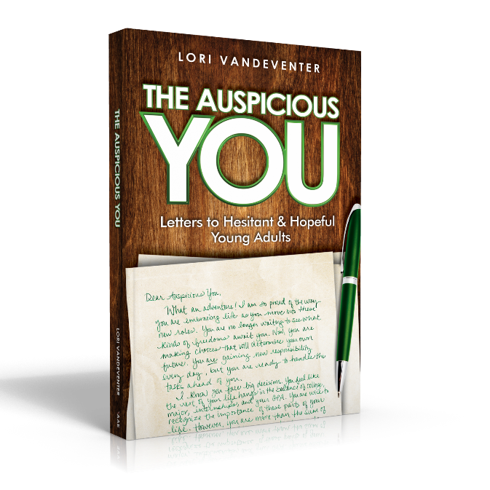
Activity: “Ready, Set, Decide!”
Objective: Assist young adults with narrowing to a specific decision and then organizing the possible choices.
Materials:
- Copy of The Auspicious You: Letters to Hesitant and Hopeful Young Adults
- Pencil or pen
- Decisions Page for Journaling
- Positive / Negative Chart for Evaluating

Process:
- Read “Ready, Set, Decide!” from The Auspicious You on pages 3-8.
- Use the Decisions Page to journal about the decisions you are facing. Write about the three biggest ones. Many times, we feel overwhelmed because we try to solve all our problems and make all our decisions at once. This is not healthy or effective. By seeing the choices you are facing side-by-side, you can prioritize and select the most important decision to focus on first.
- Use the Positive / Negative Chart for Evaluating to work through the details of this issue.
- Make your choice.
- Revisit your Chart and your decision a few days later. Give yourself time away from the work to add perspective to your choice.

Assessment: After finishing the process, review your choice. Do you have a sense of peace about the decision? After completing this work, clarity should come to you as you move forward knowing that you have wisely considered your options.

Next Steps: You can return to these pages as many times as you need to move through all the decisions you must make as you take your next steps into the adult world.



Decisions Page for Journaling: How many decisions are you trying to juggle right now? Let’s narrow it down to the top three. Record each decision below. Journal about the details of the decision, including the main issues involved.

Now that you’ve explored the major decisions you face, prioritize them. Which is the most important? The most frightening? The most time-sensitive? The order needs to make sense to you.

Once you have a feeling for which one decision to tackle first, you are ready to rank them. Use the small box in the upper left corner to order these decisions by numbering them from 1-3. For the next step, you will only focus on the top priority.
Positive / Negative Chart for Evaluating
What is the decision you are making?

What are your two main options?

Now soak up every bit of advice from the adults and mentors around you. Instead of becoming anxious about their suggestions, weigh their opinions in your mind and heart. Be attentive and ask questions.

Who is giving advice? Write their names in the circles below and write their advice in the box.

Create a positive/negative chart to show the good/bad implications for your decision by listing thoughts on both sides of the chart.

When you have all the information, settle in a quiet place by yourself. Meditate. Visualize yourself meeting your goals. Figure out which decision provides you with the most peace.

Then, YOU can make YOUR personal decision.

