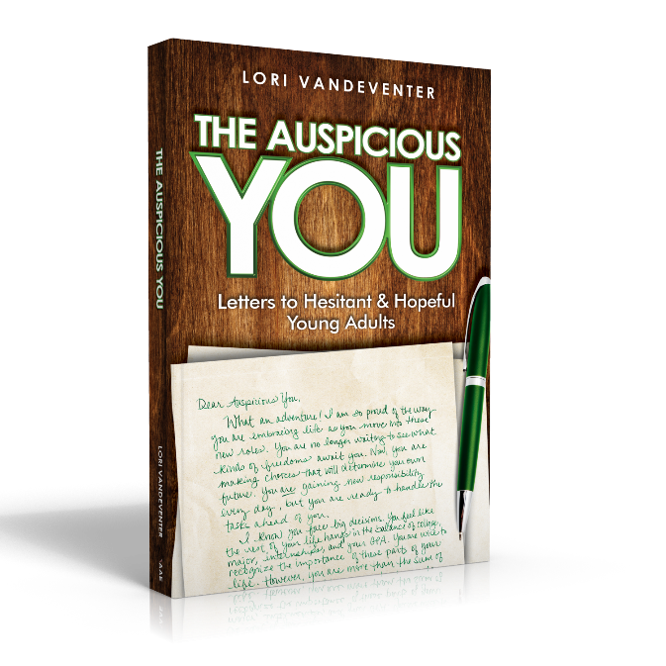
Activity: “Fluid Friendships”
Objective: Allow young adults to see the value in cultivating their friendships with many people.
Materials:
- Copy of The Auspicious You: Letters to Hesitant and Hopeful Young Adults
- Pencil or pen
- Scrapbook Page
- Pictures from various ages
- Tape or glue
- Friendship Feature Chart

Process:
- Read “Fluid Friendships” from The Auspicious You on pages 9-16.
- Attach pictures of you to each of the squares on the Scrapbook Page and then show your creative side as you represent yourself in those ages. How have you changed?
- Take time to journal on the Friendship Feature Chart. See what events you can remember. Spend effort in looking at your responsibility for both positive and negative outcomes with the friendships. Write your goals for improving friendships as they change.

Assessment: Share your realizations with your friends.

Next Steps: Hang your Scrapbook Page on your bulletin board or refrigerator and go make a new friend or three!



Scrapbook Page
Let’s see those baby faces! Find a picture of you at each grade level and attach it to the green box. Draw, design, and create understanding about you in each of these stages. Personalize the page by representing your favorite people, secret hiding places, biggest fears, common sayings, dreams, embarrassing moments, etc. of the time period in the space around the photos. Notice how much you have changed!

Friendship Feature Chart
Next step…focus on your friendships during each time frame. Jot down your memories in this feature chart.
 | Closest Friends | How did you spend time together? | Best Qualities of your Friendship? | Biggest Problems | Lessons Learned
Kindergarten

7th Grade

10th Grade

Now

When were you a good friend?

How can you be a better friend?

What goals do you have for your existing and new friendships as they evolve and change?

