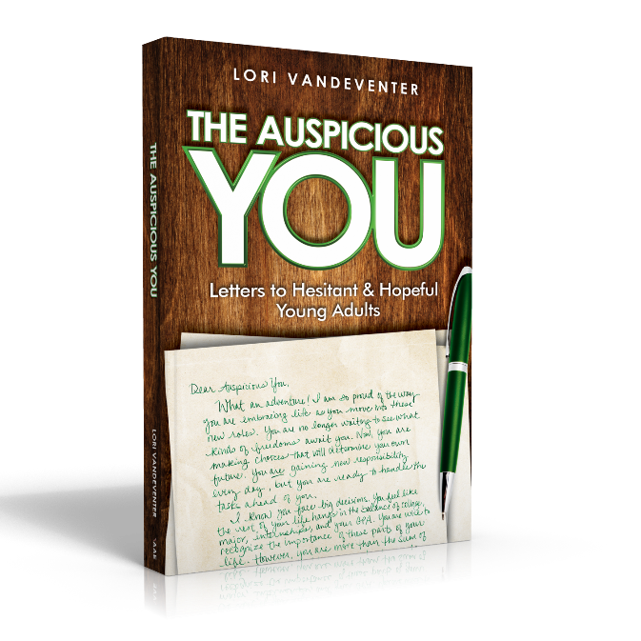
Activity: “Who Do You Love?”
Objective: Encourage young adults to change their inner voice, practice gratitude toward themselves, and set measurable goals for cultivating self-love and care.
Materials:
- Copy of The Auspicious You: Letters to Hesitant and Hopeful Young Adults
- Pencil or pen
- Inner Voice Bubbles
- Gratitude Journal
- Goals for Improvement Sheets

Process:
- Read “Who Do You Love?” from The Auspicious You on pages 39-44.
- Complete the Inner Voice Bubbles assessment to learn how you talk to yourself.
- Keep a Gratitude Journal for one week. You can find many up-to-date and valuable articles showing how your brain literally changes when you practice being thankful and embrace a grateful attitude. Check out these websites to get a beginning idea: https://positivepsychology.com/neuroscience-of-gratitude/ or https://greatergood.berkeley.edu/article/item/how_gratitude_changes_you_and_your_brain
- AFTER your week’s long assessment of your thoughts and gratitude, set your Goals for Improvement.
- This could be an on-going work so that you will continually change your focus. Revisit each step as many times as you can.

Assessment: After a week of working through the process, return to your Goals page. How have you done? Look at each specific and measurable goal to see your progress. Adjust your goals as necessary.

Next Steps: Be nice to yourself, and keep up the Gratitude Journal. Your whole brain chemistry and life outlook will improve.



Inner Voice Bubbles
Think of events that have happened to you within the last week. Results of a study night? Sporting event? Exam grade? Confrontation with a friend? Romantic evening with a special someone? Handling a problem at your job? What events stand out to you from the last week?
Explain one event in a few words in the box and then write your HONEST, inner thoughts about yourself concerning the event in the thought bubble. Fill out the charts with four different events.

Now, let’s look for a pattern.
Reread your Inner Voice Bubbles. Do you see positive or negative thoughts?
- If you see positive words (proud, hard work, smart, helpful, kind, etc.), good for you! You already see yourself in an optimistic light. Your inner voice is confident and encouraging, leading you to try new and even more challenging ambitions. Stay mindful of how you talk to yourself as you set new goals.

- If you see negative words (dumb, slow, chubby, awkward, snarky, etc.), let’s find out why. Go back to the original event and assess your behavior. If you really were mean-spirited or sarcastic, what prompted that reaction? How can you adjust your responses to events so that you are more positive?
- On the other hand, were you just living life like everyone else, but your inner voice was breaking you down to small pieces? How did this voice originate? To whom does this voice actually belong? Many times, we hear someone else criticize and be negative, and we pick up on that voice. Are you channeling your negative-filled friend or maybe your critical family member? Does this negativity belong to someone else, but you are accepting it and applying it as your own?
On this last Inner Voice Bubble, write your assessment of the pattern that you see from the week’s events in the box. Did you see negative or positive words concerning yourself? In this thought bubble, record what you think you should change.

Gratitude Journal
For one week, write 5 reasons you are thankful each day. (Reasons can be people, places, things, emotions, etc.) Big or small. What makes you grateful this week?

Date: | Date:
1 | 1
2 | 2
3 | 3
4 | 4
5 | 5

Date: | Date:
1 | 1
2 | 2
3 | 3
4 | 4
5 | 5

Date: | Date:
1 | 1
2 | 2
3 | 3
4 | 4
5 | 5

Date:
1
2
3
4
5

What have you noticed about your attitude?

How has this experiment with a Gratitude Journal proven the research that thankfulness changes lives?

Goals for Improvement

Now that you have seriously and methodically reviewed your Inner Voice as well as your Gratitude, let’s set some goals for more effective self-care. What do you need to do to take better care and show more love to yourself? How will you keep your gratitude mindset moving forward?
Effective goals are SMART. You can Google this acronym and learn many tools to help, but to simplify, just answer these questions for each goal:

Example Goal

Set your goals on the next page.

